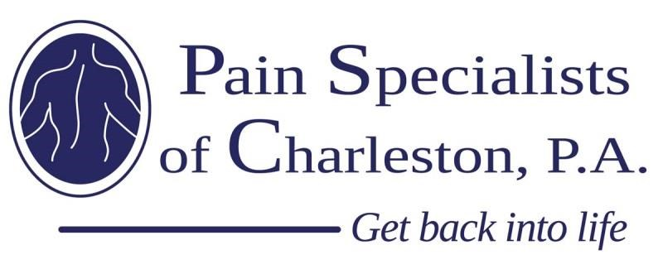
2017 Pain Specialists of Charleston Scholarship Application
Please submit your application no later than April 7th, 2017

*Please make sure you send your transcript and letter of recommendation along with the application.
Name
High School
County
Home Address
City, State, Zip
Home Phone #
Email Address
Gender
Date of Birth

Activities Involvement
Please list your high school activities (including student government, associations, clubs and other school organized activities):
Activities:

Positions of leadership:

Honor or awards:

Special achievements:

Community and Religious Involvement
Please list any community and/or religious activity involvement during high school:
Activities:

Positions of leadership:

Honor or awards:

Special achievements:

Future Pursuits
Where have you applied to college or university? (Please include Name, City, State, and Status of Application for each)

What field of study do you plan to pursue?

What is your ideal career?

Essay Portion
(500-1000 words. Please submit with application.)
Please write a 500 – 1000 word essay on what it means to give back to your community. Explain how volunteerism has shaped your character and how you plan to continue “giving BACK” as you transition into college.

Release:
I, _________________ certify that these answers are my own and this essay is my own work.
I understand my personal information and application answers will be kept strictly confidential.

Signature of Applicant ________________________________________________________

Please send completed application, transcript and letter of reference to:
Pain Specialists of Charleston, PA
Attention: 2017 Scholarship
2695 Elms Plantation – Suite A
Charleston SC 29406
Or you can scan & email it to: PLacasse@painchas.com with attention “Scholarship 2017”

